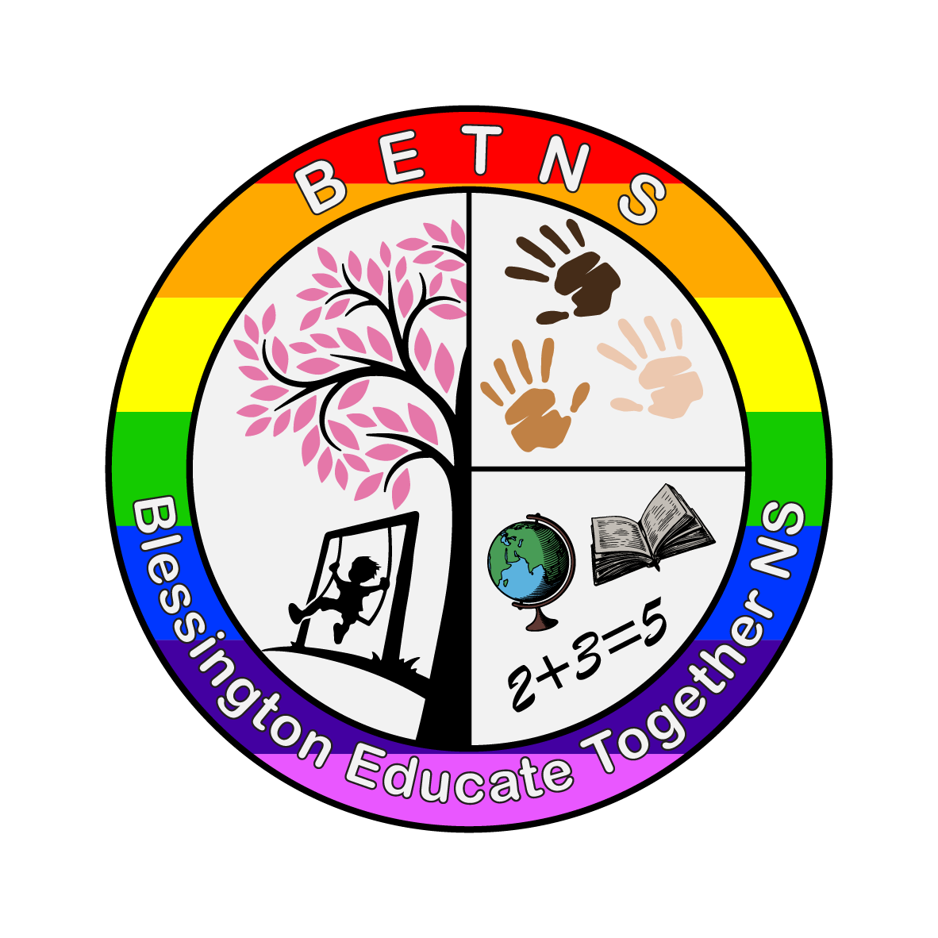

Blessington Educate Together NS

Communications Policy

Created June 2023
Review 2026

Introduction
In Blessington Educate Together NS the following tools of communication are in place:

In School
- Staff meetings
- Oral notices to teacher by the principal.
- School related events such as assemblies for example.
- Classroom visits by the principal

Home - School
The following measures endeavour to ensure co-operation between school and home:
- Email
- Phone calls
- Informal chats between staff and parents at drop-off and collection times
- Meeting parents face to face (by appointment)
- School website
- Social Media – Facebook and Twitter
- Parent-Teacher meeting
- School Reports
- Sports day, Book fair, Open Days and other school events

Hazel and Birch Rooms
There is a daily communication sheet which is used between teachers and parents. This offers feedback and updates on the child’s day in school and enables parents to inform teachers about their child’s home experience i.e. how they slept, if they ate breakfast, how the child was feeling that morning etc. This information is then used to inform teaching, learning and activities that day.

Parent/Staff Communication
All communication between parents and staff must be courteous and respectful on both sides, however urgent the issue(s) might be.

All contact with school staff must be through the school. No parent should contact a staff member on their personal mobile (if for some reason they happen to have it).

Reasons for a child’s absence should always be in the form of an email to the class teacher or by phoning the office.

Email Communications between staff and parents
Email is a very effective form of communication. It can ensure a member of staff gets the information in a fast, reliable and confidential way. There are several things to note with this form of communication.

- Emails should be used as a means of quickly contacting the class teacher about general everyday-type queries and communications such as pupil absences, requesting information etc.
- All emails should be kept short and to the point. They are not to be used in lieu of a face-to-face meeting.
- If a parent or teacher has a more serious concern, for example in relation to a child’s behaviour, they must request a face-to-face meeting (either a meeting in school or by phone – depending on the concern) by email. The email should be short, a sentence or two, outlining why the meeting is being requested in a respectful way. The principal should be ccd on these emails.
- All emails will be acknowledged within 72 hours but staff endeavour to respond before then.

Staff members can be contacted with their first name@betns.ie, for example jonathan@betns.ie.

The Board of Management can be contacted at bom@betns.ie

The Parents’ Association Committee can be contacted at pa@betns.ie
Teaching staff may ask members of the PA Committee to communicate messages on the parents’ WhatsApp Group when required.

Monitoring & Evaluation
This policy is revised every 3 years or at other times if deemed necessary.

