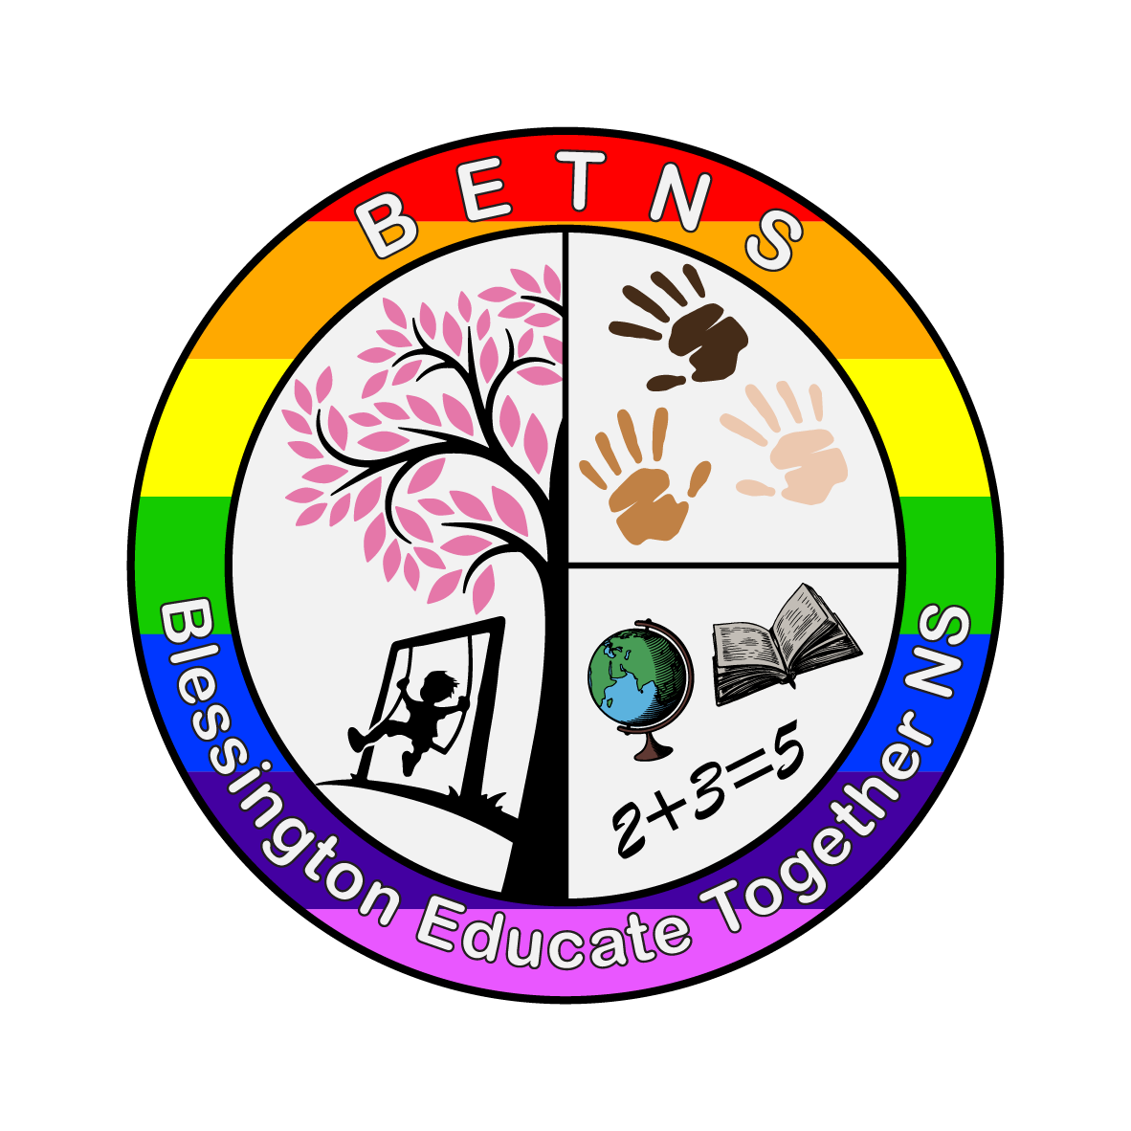
BETNS Integration Policy

Created March 2023

This policy will be reviewed in March 2025

Introduction
Blessington ETNS have opened two autism classes in recent years. The first, the Hazel Room, opened in September 2021 while the Birch Room opened its doors the following year, in September 2022. Both classes are in temporary accommodation in advance of the expansion of our school.

The following policy is intended as a guide. BETNS recognises that every child is unique and that integration will occur at different times and is based on the development and progress of each individual child.

Both integration into mainstream classes and reverse integration, whereby children from mainstream classes visit and participate in lessons in the Hazel and Birch Rooms, is practised in BETNS.

Integration will occur initially with SNA support with the hope that this will recede with time and that the child can integrate independently. For some this may not be possible and SNA supports will continue through the child’s time in BETNS.

This policy focuses on classroom integration. Integration of pupils occurs in many other instances such as yard time, assemblies, library visits, swimming, Winter Concert practice, celebratory events such as Seachtain na Gaeilge, and performances and so on.

This policy was created to support pupils, in the Hazel and Birch Rooms, to successfully and meaningfully interact with peers in mainstream classes in a secure, enjoyable and calm way and to engage with the curriculum.

School leadership, Special Education and Mainstream teachers, SNAs and parent/guardians of the Hazel and Birch Rooms consulted and advised on this policy.

Rationale
This policy was formulated so that -
- School staff, children and parent/guardians have well-defined guidelines on best practice.
- There is consistency throughout the school.
- Optimum learning experiences are provided for all children.

Aims
- To provide a teaching and learning experience that enables neurodiverse pupils in our Hazel and Birch Rooms to learn and socialise in a mainstream setting.
- To develop independent and social skills of neurodiverse children.
- To develop a sense of understanding and empathy for different types of learners and neurodiversity.

Factors to be considered in advance of Integration
The following will be considered prior to a child integrating for academic-type subjects such as Literacy and Maths for example.
The child will have some independent skills that facilitates learning such as -
- Can sit at their desk during tasks.
- Can ask for help/support (either verbally or through the use of visuals)
- Can actively listen and follow one-step, simple instructions.
- Can engage with tasks.
- Can take turns.

The following will be considered prior to a child integrating for play-based/social learning such as Aistear, PE, and SPHE
The child –
- See above for academic subjects and -
- Does not find the environment extremely upsetting in terms of sensory overloads i.e. noise, movement etc.
- Can participate in station or group tasks.

Teachers and SNAs in the Hazel and Birch Rooms are continually working with the children on the above skills to help and support integration into our mainstream classes and with reverse integration.

Length of Integration
- Integration times will be staggered beginning initially for short periods moving to longer times depending on each child.

The number of pupils integrating at the same time
The following will be considered each term –
- The supports and staffing in the Hazel and Birch Rooms. For example, how many SNAs will be needed to support integration and to support children in the Hazel and Birch Rooms.
- The number of pupils in the mainstream class.
- The supports required in the mainstream class.
- The ability of each child to meaningfully integrate. For example, one SNA may be able to support two or three children simultaneously whereas another child may need one-to-one support.
- A maximum of three pupils will integrate into one class i.e the Oak or Willow Room for example.

The number of staff required to support integration
- This depends on the number of children integrating.
- It is envisaged a minimum of two SNAs per three children. This ratio may lower depending on the children integrating and as their experience of integration increases over time.
- Timetabling of classes will attempt to merge mainstream and special class SNA supports to offer the maximum amounts of support i.e that in-class teacher supports and mainstream SNAs are available simultaneously.

Children integrating into their age/class group or into a setting more suited to their developmental age/ability
- This will depend on each individual child and their abilities, interests, and peer-relationships for example.

Planning, assessment and reviews of Integration
- It is envisaged that teachers in the Hazel and Birch Rooms meet with mainstream teachers bi-monthly to discuss objectives, resources, assessments and maintain a consistent approach to learning activities.
- School leaders and staff to meet termly.

Commencement of Integration each year
- To begin in October
- This enables children and staff to establish routines and for children to settle after the summer holidays in all class settings.

Communication and Reviews
- Communication related to integration comes in many formats including -
- Daily communication with parent/guardians involving a tick system covering that day’s schedule as well as a comments section for school staff and families.
- Arranged meetings between the class teacher.
- IEP Meetings twice yearly.
- Parent-teacher meetings (these may form part of the IEP Meeting)
- School Reports in June.

