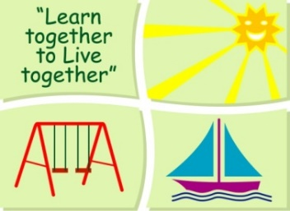
BLESSINGTON EDUCATE TOGETHER NATIONAL SCHOOL

Junior Infants Book List 2022-23
Subject | Details | Publisher
English | Just Phonics Junior Infants (42 Sounds) | Educate.ie
 | Jolly Phonics Pupil Book 1 (Black & White edition) | Jolly Learning Ltd.
 | Go With The Flow A | CJ Fallon
Maths | Planet Maths Junior Infants | Folens

Stationery
- 2 x Plastic Zip A4 folder.
- 10 x Triangular Pencils.
- 2 x Project Book Copies – 15A (40 pages)
- 3 X 40g Pritt sticks
- 4 x Bic Velleda Fine Dry Wipe Blue Marker.
- Crayons (twistables)

All Books and Copies to be covered and clearly labelled

The following expenses are to be paid on or before Monday 5th September 2022
Art Supplies, Photocopying and Materials €74
Book Rental €5
Pupil Insurance €6
Educate Together Patron Fee €15
-----------------------------
Total Amount Due €100

