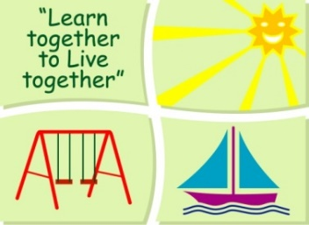
BLESSINGTON EDUCATE TOGETHER NATIONAL SCHOOL

Hazel and Birch Room Book Lists 2022-23
Dear parents/guardians, as each child has an individual plan the class teacher will be in touch during September to identify books and resources required. Please ensure your child has purchased the stationary below in advance of the school year. Thank you.

Stationery
- 2 x Plastic Zip A4 folders
- 2 x Project Book Copies – 15A (40 pages)
- 10 x Triangular Pencils.
- 3x 40g Pritt sticks
- 4 x Bic Velleda Fine Dry Wipe Blue Marker.
- Crayons (twistables)

All Books and Copies to be covered and clearly labelled

The following expenses are to be paid on or before Monday September 5th

Art Supplies, Photocopying and Materials €74
Book Rental €5
Pupil Insurance €6
Educate Together Patron Fee €15
-----------------------------
Total Amount Due €100

