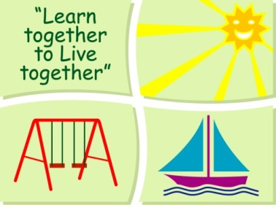
BLESSINGTON EDUCATE TOGETHER NATIONAL SCHOOL

Sixth Class Book Lists 2022-23

Subject | Details | Publisher
English | Spellings For Me | Included in Book Rental
 | Starlight 6 | Folens
 | Read at Home 6 | Included in Book Rental
 | English Novels | Included in Book Rental
Irish | Am Don Léamh 6 | Folens
 | Mo Lámhleabhar Gramadaí Rang a Cuig 5 | Educate.ie
Maths | Planet Maths 6 | Folens
 | Mental Maths 6 | Prim Ed.
 | Mad 4 Maths 6 | Gill and Macmillan
SESE | Just Maps 6th Class | Educate .ie
 | Unlocking SESE | Included in Book Rental
 | Primary School Atlas | Included in Book Rental

Stationery
- 1 88 page copy and 2 maths copies.
- 1 Nature Study A4 Hardback Copy (Continue using last year’s book if there is still space)
- 1 A4 Hardback Copy
- 1 Sketch Pad
- Mathematical Set with a compass and a protractor.
- Slim whiteboard marker x3
- 3 x 40g Pritt Stick (with names on them) 1 ruler 30cm & 1 scissors.
- 3 x ball point blue pens, 2 x red & black pens
- 2 x HB Pencils, 2X black markers/sharpie, a pack of Colouring Pencils or markers,
rubber & sharpener.

All Books and Copies to be covered and clearly labelled

The following expenses are to be paid on or before 5th September 2022

Art Supplies, Photocopying and Materials €74
Book Rental €15
Pupil Insurance €6
Educate Together Patron Fee €15
Total Amount Due €110

