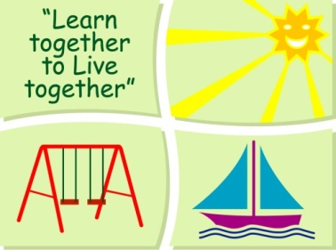
BLESSINGTON EDUCATE TOGETHER NATIONAL SCHOOL

Fourth Class Book List 2022-23

Subject | Details | Publisher
English | Starlight 4 | Folens
 | Master Your Grammar 4 | CJ Fallon
 | Cursive Go With the Flow F 4th Class | CJ Fallon
 | My Read at Home 4 (New Edition) | CJ Fallon
 | English Novels/Readers | Included in Book Rental
 | Spellings for Me | Included in Book Rental
Irish | Bua na Cainte 4 | EdCo
Maths | New Wave Mental Maths 4 | Prim-Ed. Publishing
 | Planet Maths 4 Pupil Textbook | Folens
SESE | Unlocking SESE 4 | Included in Book Rental
 | Primary School Atlas | Included in Book Rental
Misc. | My Homework Diary - New Edition (2021) | Just Rewards

Stationery
- 3 x Exercise copies (88 pages)
- 2 x Sum Copies C3 (88 page 7mm Sq.)
- 1 x Nature Study Copy (40 pages)
- 1 x A6 Notebook
- 4 x HB Pencils, 1 x Red Pen, 1 x Blue pen
- 30cm Ruler, Rubber, Sharpener
- Colouring Pencils.
- 2 x 40g Pritt Stick (with names on them).
- 4 x Bic Velleda Fine Dry Wipe Blue Marker (with names on them).
- 1 x A4 Ringbinder & polypockets

All Books and Copies to be covered and clearly labelled on the front

The following expenses are to be paid on or before 5th September 2022

Art Supplies, Photocopying and Materials €74
Book Rental €15
Pupil Insurance €6
Educate Together Patron Fee €15
Total Amount Due €110

