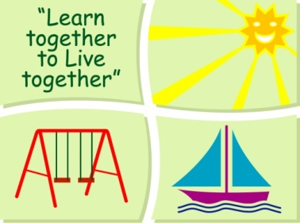
BLESSINGTON EDUCATE TOGETHER NATIONAL SCHOOL

Third Class Book List 2022-23

Subject | Details | Publisher
English | Over the Moon 2nd class Skills book | Gill Education
 | Master Your Grammar 3 | CJ Fallon
 | Cursive Go With the Flow E 3rd Class | CJ Fallon
 | My Read at Home 3 (New Edition) | CJ Fallon
 | English Novels/Readers | Included in Book Rental
 | Spellings For Me | Included in Book Rental
Irish | Cosáin na Gealaí Rang a Dó Leabhar Scileanna | Gill Education
 | Rírá 3 | CJ Fallon
Maths | New Wave Mental Maths 3 | Prim-Ed. Publishing
 | Planet Maths 3 Pupil Textbook | Folens
 | Tip Top Tables | Folens
 | My Problem Solving Journal 3 | Folens
SESE | Explore With Me 2 | EdCo
Misc. | My Homework Diary - New Edition (2021) | Just Rewards

Stationery
- 3 x Exercise copies (88 pages)
- 2 x Sum Copies C3 (88 page 7mm Sq.)
- 1 x Nature Study Copy (40 pages)
- 1 x A6 Notebook
- 4 x HB Pencils,1 x Red Pen, 1 x Blue pen
- 30cm Ruler, Rubber, Sharpener
- Colouring Pencils.
- 3 x 40g Pritt Stick (with names on them).
- 4 x Bic Velleda Fine Dry Wipe Blue Marker (with names on them)..
- A4 ringbinder & polypockets

All Books and Copies to be covered and clearly labelled on the front

The following expenses are to be paid on or before 5th September 2022

Art Supplies, Photocopying and Materials €74
Book Rental €15
Pupil Insurance €6
Educate Together Patron Fee €15
Total Amount Due €110

