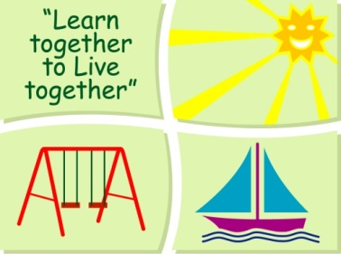
BLESSINGTON EDUCATE TOGETHER NATIONAL SCHOOL

First Class Book List 2022-23

Subject | Details | Publisher
English | Over the Moon 2nd class Skills book | Gill Education
 | Cursive Go With the Flow C 1st Class | CJ Fallon
 | My Read at Home 1 (New Edition) | CJ Fallon
 | English Novels/Readers | Included in Book Rental
 | Spellings For Me | Included in Book Rental
Irish | Cosáin na Gealaí Rang a Dó Leabhar Scileanna | Gill Education
Maths | New Wave Mental Maths 1 | Prim-Ed. Publishing
 | Planet Maths 1 Pupil Textbook | Folens
 | Tables Champion 1 | Educate.ie
SESE | Explore With Me 2 | EdCo
Misc. | My Homework Diary - New Edition (2021) | Just Rewards

Stationery
- 3 x Junior Writing Copy - 15mm Ruling (40 pages)
- 2 x Junior Sum Copies 10mm Sq. (40 pages)
- 1 x Nature Study Copy (40 pages)
- 1 x A6 Notebook
- 4 x HB Pencils
- 15cm Ruler, Rubber, Sharpener
- Colouring Pencils.
- 3 x 40g Pritt Stick (with names on them).
- 4 x Bic Velleda Fine Dry Wipe Blue Marker (with names on them).
- A4 zip folder

All Books and Copies to be covered and clearly labelled on the front

The following expenses are to be paid on or before 5th September 2022

Art Supplies, Photocopying and Materials €74
Book Rental €15
Pupil Insurance €6
Educate Together Patron Fee €15
Total Amount Due €110

