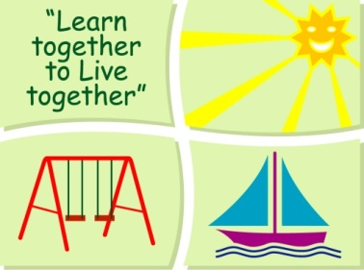
BLESSINGTON EDUCATE TOGETHER NATIONAL SCHOOL

Third Class Book List 2020-2021
Subject | Details | Publisher
English | Spell It 3rd Class | Folens
 | Word Wizard 3 | Gill Education
 | Just Cursive Handwriting Third Class | Just Rewards Sticker Company
 | My Read at Home 3 | CJ Fallons
 | English Novels/Readers | Included in Book Rental
Irish | Léigh sa Bhaile Leabhar C | CJ Fallon
Maths | New Wave Mental Maths 3 | Prim-Ed. Publishing
 | Planet Maths 3 | Folens
SESE | Just Maps 3rd Class | Educate.ie

Stationery

- 4 x 88 page copies.
- 2 x Sum Copies C3 (88 page 7mm. Sq.)
- 3 x 40g Pritt Stick (with names on them) 1 ruler 30cm & 1 scissors.
- 4 x Bic Velleda Fine Dry Wipe Blue Marker.
- 1 x Red Pen 1x Blue Pen
- 2 x HB Pencils, Colouring Pencils, Rubber, ruler & Sharpener.

All Books and Copies to be covered and clearly labelled

The following expenses are to be paid on or before Monday September 7th

Art Supplies, Photocopying and Materials €85
Book Rental €14
Pupil Insurance €6
Educate Together Patron Fee €15
_____
Total Amount Due €120

