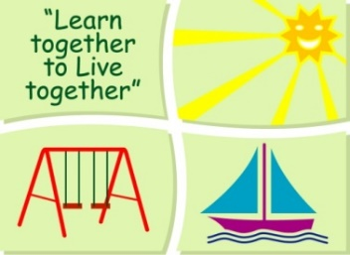
BLESSINGTON EDUCATE TOGETHER NATIONAL SCHOOL

Junior Infants Book List 2020-2021
Subject | Details | Publisher
English | Just Phonics Junior Infants (42 Sounds) | Educate.ie
 | Jolly Phonics Pupil Book 1 (Black & White edition) | Jolly Learning Ltd.
 | Just Cursive Handwriting Junior Infants | Just Rewards Sticker Company
Irish | Bua na Cainte B | Edco
Maths | Planet Maths Junior Infants | Folens

Stationery
- 1 Plastic Zip A4 folder.
- 4 x Triangular Pencils.
- 3 X 40g Pritt sticks
- 4 x Bic Velleda Fine Dry Wipe Blue Marker.
- Crayons (twistables)

All Books and Copies to be covered and clearly labelled

The following expenses are to be paid on or before Monday September 7th

Art Supplies, Photocopying and Materials €85
Book Rental €14
Pupil Insurance €6
Educate Together Patron Fee €15
-----------------------------
Total Amount Due €120

