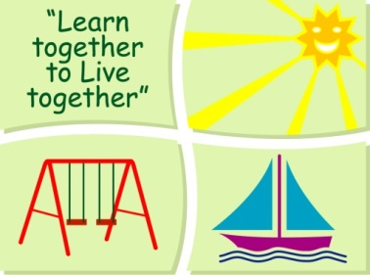
BLESSINGTON EDUCATE TOGETHER NATIONAL SCHOOL

Fourth Class Book Lists 2020-2021

Subject | Details | Publisher
English | Spell It 4 | Folens
 | Word Wizard 5 | Gill Education
 | Dictionary | Any children’s dictionary
 | My Read at Home 4 | CJ Fallons
 | English Novels | Included in Book Rentals
Irish | Abair Liom F (Orange) | Folens
Maths | Planet Maths 4 | Folens
 | Mental Maths 4 | Prim Ed.
SESE | Just Maps 4th Class | Educate.ie
 | Unlocking SESE 5 | Included in Book Rental
 | Primary School Atlas | Included in Book Rental

Stationery
- 2 x 88 page copies.
- 2x Sum copies
- 1 A4 Display book with pockets
- 1 Nature Study A4 Hardback Copy
- 1 A5 Hardback Copy
- 1 Sketch Pad
- Tin Whistle
- 3 x 40g Pritt Stick (with names on them) 1 ruler 30cm & 1 scissors.
- 4 x Bic Velleda Fine Dry Wipe Blue Marker.
- 3 x ball point blue pens, 2 x red & black pens
- 2 x HB Pencils, Colouring Pencils or markers, rubber & sharpener.
- Mathematical Set

All Books and Copies to be covered and clearly labelled

The following expenses are to be paid on or before Monday September 7th

Art Supplies & Photocopying €85
Book Rental €14
Pupil Insurance €6
Educate Together Patron Fee €15
____
Total Amount Due €120

