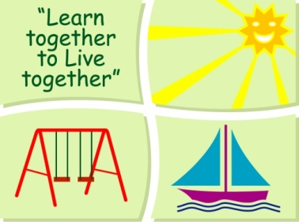

BLESSINGTON EDUCATE TOGETHER NATIONAL SCHOOL

First Class Book List 2020-2021

Subject | Details | Publisher
English | Spell It 1st Class | Folens
 | Word Wizard 1 | Gill Education
 | Just Cursive Handwriting First Class | Just Rewards Sticker Company
 | My Read at Home 1 | CJ Fallons
 | English Novels/Readers | Included in Book Rental
Irish | Abair Liom C | Folens
Maths | New Wave Mental Maths 1 | Prim-Ed. Publishing
 | Planet Maths 1 | Folens
SESE | Unlocking SESE 1st Class | Folens

Stationery
- 2 x 88 page copies.
- 2 x Sum Copies C3 (88 page 7mm Sq.).
- 1 x Red Pen, 1 x Blue pen.
- 3 x 40g Pritt Stick (with names on them).
- 4 x Bic Velleda Fine Dry Wipe Blue Marker.
- 2 x HB Pencils, Colouring Pencils, Rubber, ruler & Sharpener

All Books and Copies to be covered and clearly labelled

The following expenses are to be paid on or before Monday September 7th

Art Supplies, Photocopying and Materials €85
Book Rental €14
Pupil Insurance €6
Educate Together Patron Fee €15
-----------------------------
Total Amount Due €120

