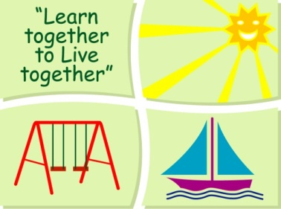
BLESSINGTON EDUCATE TOGETHER NATIONAL SCHOOL

Sixth Class Book List 2019-2020
Subject | Details | Publisher
English | Spellbound 6 | CJ. Fallon
 | Word Wizard 6 | Gill Education
 | Just Cursive Handwriting.  (handwriting programme 4) | Just Rewards Sticker Company
 | Read at Home 6 | Included in Book Rental
 | English Novels | Included in Book Rental
Irish | Am Don Léamh 5 | Folens
 | Bulagh Bos 6 | Included in Book Rental
 | Graiméar le Chéile 5 and 6 | EDCO
Maths | Mental Maths 6 | Folens
 | Planet Maths 6 | Folens
 | Planet Maths Satellite Book 6 | Folens
SESE | Just Maps 5th Class | Educate.ie
 | Unlocking SESE 5 | Included in Book Rental
 | Philips Post Primary School Atlas | Included in Book Rental
Homework Diary |  | Supplied free in school
Stationery
- 4 x 88 page copies.
- 3 x Sum Copies C3 (88 page 7mm. Sq.)
- 1 A4 Display book with pockets
- 1 Nature Study A4 Hardback Copy
- 1 A5 Hardback Copy
- 1 Sketch Pad
- Tin Whistle (D)
- 3 x 40g Pritt Stick (with names on them) 1 ruler 30cm & 1 scissors.
- 3 x ball point blue pens, 2 x red & black pens
- 2 x HB Pencils, Colouring Pencils, Rubber & Sharpener.
- Mathematical Set
All Books and Copies to be covered and clearly labelled
The following expenses are to be paid on or before September 9th
Art Supplies, Photocopying and Materials €85
Book Rental €15
Pupil Insurance €6
Educate Together Patron Fee €15 ____
Total Amount Due €121

