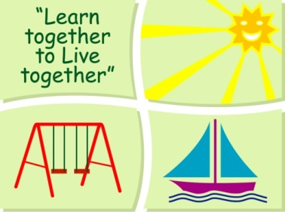
BLESSINGTON EDUCATE TOGETHER NATIONAL SCHOOL

Senior Infants Book List 2019-2020
Subject | Details | Publisher
English | Spellbound Senior Infants | CJ. Fallon
 | Just Phonics Senior Infants | Educate.ie
 | Rainbow Skills Book B | C.J. Fallon
 | Just Cursive Handwriting. (handwriting programme for Junior Infants) | Just Rewards Sticker Company
Irish | Bua na Cainte A | Educational Company
Maths | Planet Maths Senior Infants | Folens
Homework Diary |  | Supplied free in school

Stationery
- 3 x 15A Project Book.
- 1 x Sketch pad
- 1 Plastic zip A4 folder.
- 4 x Triangular Pencils.
- Crayons (twistables)

All Books and Copies to be covered and clearly labelled

The following expenses are to be paid on or before September 10th

Art Supplies, Photocopying and Materials €85
Book Rental €15
Pupil Insurance €6
Educate Together Patron Fee €15
-----------------------------
Total Amount Due €121

