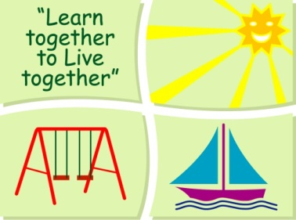
BLESSINGTON EDUCATE TOGETHER NATIONAL SCHOOL

Second Class Book List 2019-2020
Subject | Details | Publisher
English | Spellbound 2 | CJ. Fallon
 | Word Wizard 2 | Gill Education
 | Just Cursive Handwriting. (handwriting programme 2) | Just Rewards Sticker Company
 | English Novels | Included in Book Rental
Irish | Bua na Cainte 1 | Educational Company
Maths | New Wave Mental Maths 2 | Prim-Ed. Publishing
 | Planet Maths 2 | Folens
 | Planet Maths 2 Activity Book | Folens
SESE | Explorers SESE 2 | Folens
Homework Diary |  | Supplied free in school

Stationery
- 4 x 88 page copies.
- 3 x Sum Copies C3 (88 page 7mm Sq.).
- 1 x A5 Hardback Copy.
- 1 x Red Pen, 1 x Blue pen.
- 3 x 40g Pritt Stick (with names on them).
- 2 x HB Pencils, Colouring Pencils, Rubber & Sharpener
All Books and Copies to be covered and clearly labelled
The following expenses are to be paid on or before September 10th
Art Supplies, Photocopying and Materials €85
Book Rental €15
Pupil Insurance €6
Educate Together Patron Fee €15
-----------------------------
Total Amount Due €121

