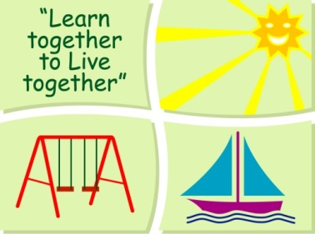
BLESSINGTON EDUCATE TOGETHER NATIONAL SCHOOL

Junior Infants Book List 2019-2020
Subject | Details | Publisher
English | Just Phonics Junior Infants (42 Sounds) | Jolly Learning Ltd.
 | Jolly Phonics Pupil Book (Black & White) | Jolly Learning Ltd.
 | Rainbow Skills Book A | C.J Fallon
 | Just Cursive Handwriting. (handwriting programme for Junior Infants) | Just Rewards Sticker Company
Irish | Bua na Cainte A | Educational Company
Maths | Planet Maths Junior Infants | Folens
Homework Diary |  | Supplied free in school

Stationery
- 3 x 15A Project Book.
- 1 x Sketch pad
- 1 Plastic Zip A4 folder.
- 4 x Triangular Pencils.
- Crayons (twistables)

All Books and Copies to be covered and clearly labelled

The following expenses are to be paid on or before September 10th

Art Supplies, Photocopying and Materials €85
Book Rental €15
Pupil Insurance €6
Educate Together Patron Fee €15
-----------------------------
Total Amount Due €121

