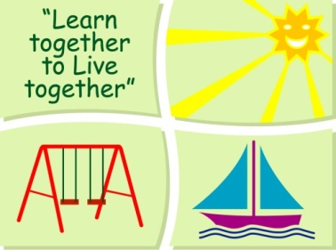
BLESSINGTON EDUCATE TOGETHER NATIONAL SCHOOL

Junior Infants Book Lists 2018-2019
Subject | Details | Publisher
English | Rainbow English Language Programme  Skills Book A | C. J. Fallon
 | Jolly Phonics Pupil Book (Black & White) | Jolly Learning Ltd.
 | Just Phonics Senior Infants (42 sounds) | Educate.ie
 | Just Cursive Handwriting Junior Infants | Just Rewards Sticker Company
Irish | Bua na Cainte B | Educational Company
Maths | Planet Maths Junior Infants | Folens

Stationery
- 2 x project book 15 A (copybook)
- 2 x sketchpad
- 1 x set of twistable crayons.
- 4 x chubby triangle pencils
- Plastic zip folder for homework

All Books and Copies to be covered and clearly labelled

The following expenses are to be paid on or before September 10th

Art Supplies & Photocopying €85
Book Rental €15
Pupil Insurance €5
Educate Together Patron Fee €15
-----------------------------
Total Amount Due €120

