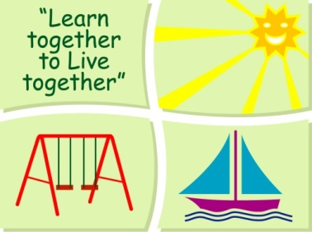
BLESSINGTON EDUCATE TOGETHER NATIONAL SCHOOL

Sixth Class Book Lists 2018-2019
Subject | Details | Publisher
English | Spellbound 6 | CJ. Fallon
 | Word Wizard 5 | Gill Education
 | Just Cursive Handwriting. (handwriting programme 4) | Just Rewards Sticker Company
English Novels |  | Included in Book Rental
Irish | Ceartlitriú 5 | C.J.Fallon
Maths | New Wave Mental Maths 6 | Prim-Ed. Publishing
 | Planet Maths 6 | Folens
 | Planet Maths 6Activity Book | Folens
SESE |  | Included in Book Rental
Homework Diary |  | Supplied free in school
Stationery
- 7x 88 page copies.
- 4 x Sum Copies C3 (88 page 7mm. Sq.)
- 2 Hardback A4 copies (not ring binder) .1 Plastic envelope folder (not ring binder).
- 1 x 40g Pritt Stick (with names on them) 1 ruler 30cm & 1scissors.
- 1 ring binder hardback A4 folder and poly pockets.
- Mathematical Set.
- 2 x ball point red/blue/black pens
- 1 x set of Twistable Crayons.
- Pencils, Rubber & Sharpener.
All Books and Copies to be covered and clearly labelled

The following expenses are to be paid on or before September 10th

Art Supplies & Photocopying €85
Book Rental €15
Pupil Insurance €5
Educate Together Patron Fee €15
-----------------------------
Total Amount Due €120

