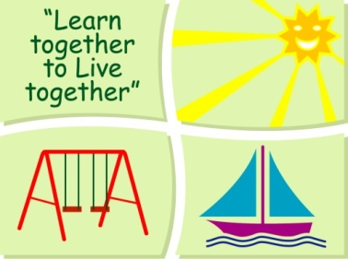
BLESSINGTON EDUCATE TOGETHER NATIONAL SCHOOL

First Class Book Lists 2018-2019
Subject | Details | Publisher
English | Spellbound 1 | C.J. Fallon
 | Word Wizard 1st Class | Gill Education
 | Exercise Your English 1 | Educational Company
 | Just Cursive Handwriting (handwriting programme 1) | Just Rewards Sticker Company
English Novels |  | Included in Book Rental
Irish | Bua na Cainte 2 | Educational Company
Maths | New Wave Mental Maths 1 | Prim-Ed. Publishing
 | Planet Maths 1 | Folens
 | Planet Maths 1 Activity Book | Folens
SESE | Small World 2nd Class | C.J. Fallon
Homework Diary |  | Supplied free in school
Stationery
- 10 x project book 15A copies.
- 2 x Junior Sum Copies (20mm Square).
- 1 Plastic envelope folder (not ring binder).
- 2 x 40g Pritt Stick (with names on them) 1 ruler 30cm & 1 scissors.
- 1 x 16x10 Notebook (for spellings).
- 1 x set of Twistable Crayons.
- Pencils, Rubber & Sharpener.

All Books and Copies to be covered and clearly labelled

The following expenses are to be paid on or before September 10th

Art Supplies & Photocopying €85
Book Rental €15
Pupil Insurance €5
Educate Together Patron Fee €15
-----------------------------
Total Amount Due €120

